After successfully performing a Git install, the next step in learning Git is to master the following five basic git commands: init, config, add, status and commit. This git tutorial for beginners will take you step by step through each of these commands, demonstrating how easy the Git source code management tool is to use.

The git init command
The first of the five basic git commands you need to learn is init. This command does exactly what you would expect it to do - it initializes a git repository.
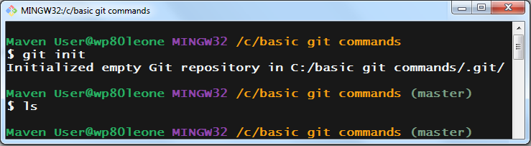
Figure #. The first basic Git command beginners need to learn: git init.
If you explore the folder in which the git init command is run, you will notice a hidden folder named .git, with a number of subfolders named hooks, info, objects and refs. These are the folders in which Git will manage and maintain the entire source history of your recently initialized Git repo.
Git only needs to be installed once on a computer, but once installed, a computer can create an unlimited number of Git repositories, so long as those repositories are not nested within each other. Each repository is self-contained, and is completely unaware of any other Git repositories that might exist on your computer.

The git config command
This is probably the least interesting of the five basic git commands you encounter in this git tutorial for beginners. But you do need to learn the git config command, because not knowing about it can really cause a great deal of confusion when it comes time to make your first git commit.
After Git is installed, before any code can be committed, the tool needs to know the committers name and email address. This is achieved by running the git config command twice, the first time providing a user.name switch the second time providing a user.email switch.
/c/ basic git commands (tutorial)
$ git config --global user.name "Learn Git"

/c/ basic git commands (tutorial)
$ git config --global user.email "basic@commands.com"

There are three scopes for git configuration: local, global and system. Global trumps local and system trumps global. The best practice is to set the user.name and user.email properties at the global level and then not worry about them ever again.

Where does Git store global config?
If you look in the .git directory of any repository, you will find an extensionless file named config. Inside this file all local git configuration is stored.
Under the user's profile folder there is a file named .gitconfig and it is within this file that all global git configuration is stored.
Finally, Git system configuration is saved in a file named gitconfig which can be found in the ming\etc subfolder of your git installation..
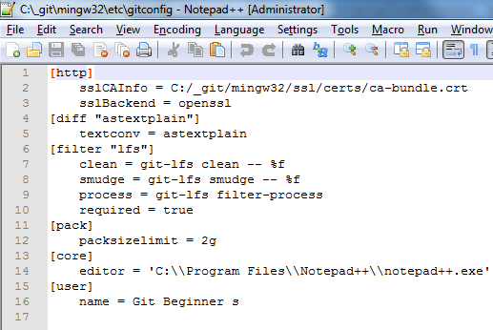
Figure #. Git system configuration data saved in the etc subfolder of the installation.

The git add command
Not every file you create needs to be committed to source code control. Before making a commit to the Git repo, a developer must explicitly identify which files need to be grouped together as part of the commit. This is done by issuing a git add command and naming the files that should be included in the next commit.
In the following set of Bash shell entries, three files are created using the echo command, namely five.html, basic.html and commands.html.
/c/ basic git commands (tutorial)
$ echo "5" > five.html && echo "b" > basic.html && echo "c" > commands.html

/c/ basic git commands (tutorial)
$ ls
basic.html commands.html five.html

However, despite the fact that all three files are in the directory in which the Git repository was initialized, only the ones associated with a git add command will be part of the next commit. So if I want to leave the command.html file of the next commit, I simply don't name it in a git add command.

/c/ basic git commands (tutorial)
$ git add basic.html

/c/ basic git commands (tutorial)
$ git add five.html

The technical term for identifying which files will be part of the next commit is staging, and when you issue a git add command on a file, it is said that you have staged the file in the Git index. The Git index is what keeps track of all of the files that are to be part of the next commit.
If you have changed a large number of files, and want them all to be staged, you can issue the git add space dot command. This will add every change file to the index, with the exception of anything listed in the .gitignore file.

The git status command
Sometimes a developer loses track of what has and what has not been added to the staging area, which is why git status is the next command we look at in this git tutorial for beginners. The git status command will tell you which branch you are on, which files are staged to be committed, and which files are untracked because they have not been added to the index. The git status command is a great tool for quickly understanding the current state of your working tree.
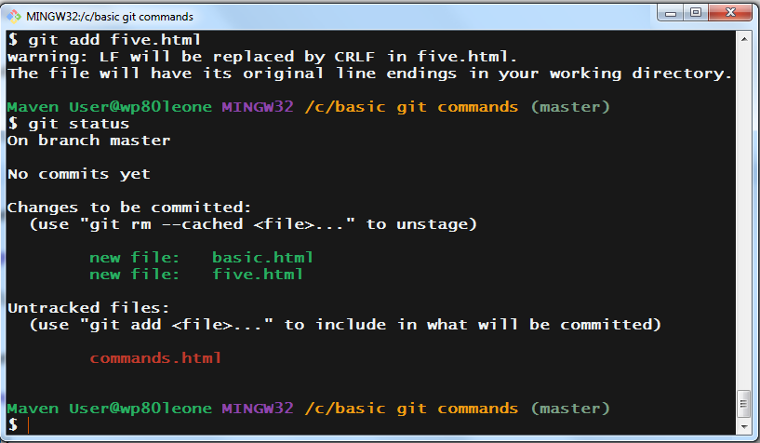
Figure #. Learn th git status command so you can display the state of the working tree.

The git commit command
The last of the five basic git commands we will learn in this git tutorial for beginners is git commit.
To permanently save changes into the Git repository, a commit must be issued, and that commit must be associated with a message describing the commit. Furthermore, Git keeps track of the name and email address of the user making the commit, which is why those pieces of information needed to be provided through the git config command.
When issuing a commit, the -m switch should be used to provide a text message describing the commit. If the -m command is not used, Git will ask for input through a Vi editor in the Bash shell, which tends to throw Git beginners for a loop. So make life easy for yourself and always include the -m switch.
/c/ basic git commands (tutorial)
$ git commit -m "basic git commands tutorial completed!"
[tutorial (root-commit) d6a80cf] basic git commands tutorial completed!
2 files changed, 2 insertions(+)
create mode 100644 basic.html
create mode 100644 five.html

The five basic git commands to learn
So those are the five basic git commands every software developer needs to master in order to learn Git and be able to use Git at a functional level. If you can get comfortable with the git init, config, add, commit and status commands, you are on your way to transforming from a git beginner into a git expert.

